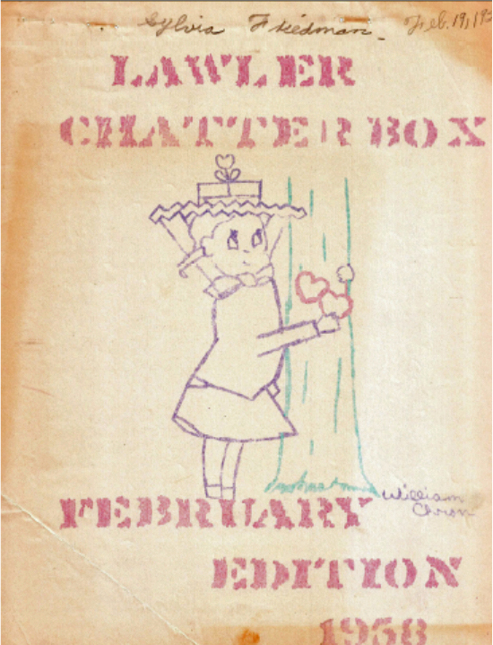
Sylvia Friedman Elsner has treasured this newsletter for almost 58 years, here is a typed copy from “The Chatterbox” - February 1958, courtesy of Sylvia Friedman Elsner
“CHATTERBOX”

PUBLISHED BY THE SIXTH GRADE CLASS
OF
LAWLER ELEMENTARY SCHOOL
MISS FLORENCE PATE, PRINCIPAL
MISS LOIS LAMAN, 6TH GRADE TEACHER

*STAFF*
Editor-In-Chief: Mickey Johnson
Assistant Editor: Jerry Banks
Story Editor: David Johnston
Poetry Editor: Jeanne Hale
Radio & T.V. Editor: Billy Jo House
Book Review Editor: Tony Martin
Safety Editor: Carol Boyd
Health Editor: Danny Tarver
Society Editor: Shirley Bray
Hobby Editor: Sally Belote
Artist: William Chron
Jokes & Puzzles: Dany McDougl

SAINT VALENTINE’S DAY
Saint Valentine’s Day is on February 14th. Originally it was a custom to draw lots to decide which young men and women should be their Valentine for the coming year. The couples would exchange their gifts, and sometimes become engaged. Candy and flowers are still commonly used. American children exchange Valentines.
Some of the early Valentines were made long ago. One of the oldest known Valentines was made in 1790. In the 1900’s raised paper designs were used. Frilly fan shaped Valentines were used in 1875. Comic Valentines were used in 1895. The Kate Greenaway style was popular in the 1900’s.
In 1937 clever cards were drawn with a verse or two. Kiddies’ style cards are popular now.
Mickey Johnson – Editor-in-Chief
Jerry Banks – Assistant Editor

SPOT’S DIARY
Dear Diary,
Today was another day when everything went wrong. Again that old yellow bus came along in the morning and took my master Bobby to that place called “school”. With Bobby gone I scratched my head trying to figure out what to do with myself. You know what happened? That woman Bobby calls “ma” came and took me by the neck. “Fleas,“ Bobby’s mother said, and put me in a tub of water and started scrubbing me with some terrible smelling stuff that was all foamy and got in my eyes and nose. I got away in time before she rubbed all my hair off. Then I rolled myself out in the yard to get rid of that horrible smell. Then I went to meet Bobby, I could see right away he’d been rolling in somebody’s yard too. He looked fine to me….but you should have heard “Ma!” She took both of us and hustled us in the house. Then she put Bobby in a big tub and scrubbed Him.
Bob Smith
* * * *
CLASS NEWS
Miss Burgess’
4th and 5th Grades
On January 20, 1958 Miss Burgess’ 4th & 5th grade classes elected officers. They are as follows:
FIFTH GRADE:
President - Beth Howell
Vice-President – Harry Mullins
Secretary – Libby Shanks
Treasurer – Cheryl Simon
Line Captains – Cheryl Simon and Donald Sheppard
Host & Hostess – Pete Burns and Kathie Wessels
Housekeepers – Kathie Wessels and Barbara Cherry
FOURTH GRADE:
Line Captains – Sharon Matthews and Frank Homes President – Cathy Seale
Vice-President – Boots Davis
Secretary – Sharon West
Treasurer – Gene Morphis
Host & Hostess – Gene Morphis and Susan Neal

LIFE OF ANDREW JACKSON
Born – 1787 Died – 1846
Andrew Jackson was the seventh president of the United States of America.
Andrew was unwilling to learn to speak or write correct English when he was a boy.
During the Revolutionary war he was thrown into prison. There he had the smallpox. His mother nursed him back to health.
His mother died of Yellow Fever on the ship on which she nursed American prisoners. His mother gave him some good advice before she died.
Janie Winfield, Miss Burgess’ 4th Grade
* * * *
POP, TOP, AND MOP
We three booms of the store. One of us is worth more. Our names are Pop, Top, and Mop. One of us foams like Pop. The second spins like a Top. The last has hair like a Mop. That’s the end of my tale. It was told by Mr. Quail.
Paul Goodman
* * * *
DaVY, MaISIE, and NO-NAME
We three bombs of the Navy. One of us is named Davy. The second one is named Maisie. She is very lazy. The third one isn’t named. He can’t even be tamed. That’s the end of my story. It was told by Peter Lorre.
Paul Goodman
DAVE, FAYE, AND PAT
We three bums in a cave. One of us is named Dave. The second one is named Fay. She was born in the month of May. The third one is named Pat. Once he swallowed a gnat. That’s the end of my story. So I can’t tell you anymore.

MRS. DENNIE’S FIRST & THIRD GRADES
Do you like this cold weather? We do, especially the snow—we wear thick clothing to keep us warm.
This is good weather for learning to read, too. We are reading library books now—Reading is lots of fun.
In health we have been learning how to keep sickness away. We are trying hard to keep our hands clean and to keep them away from our face. We are trying to cover every sneeze and cough too.
We, the Third Grade, have been writing poetry. We would like to share some of our poems with you.
* * * *
FUN WITH A KITE
I saw a kite up in the sky, And I heard the wind cry. The kite was red. I heard the wind sing up ahead.
Sylvia Friedman
* * * *
WATCHING MY SHADOW
I watch my shadow every day I watch it wash, I watch it play I watch it dance, I watch it sing. I watch it do every little thing.
Johnnie Rogers
* * * *
SNOW
I like to play in the snow, It’s really ice you know, I like the way it sparkles and glitters, Just like the stars at night, That give such a pretty light
Warren Hatcher
* * * *
PAPER BOATS
My little paper boats, They look like little coats Little floats, I wish they were like paper boats.
Betty Dianne Wetzel

RIDDLES
What’s red and yellow and eats rocks?
(A red & yellow rock eater).
What is black and white and red all over?
(A Newspaper)
* * * *
Tom: Guess what? Harry: What? Tom: I’m going to trade in my hi-fidelity record player Harry: Why Tom: I put an Elvis Presley record in it and it spit it out.
Tommy Shivler
* * * *
RED CROSS NEWS
The Junior Red Cross has held three council meetings in our school auditorium. Our president presided at each of these meetings.
In September we held our most important Red Cross drive. We filled eighteen boxes. We turned in $30.29.
This year we have sent favors to St. Joseph Hospital for each holiday. We wish to thank Mrs. White our P.T.A. president for delivering the favors.
The sixth grade is planning to send an interesting album to Venezuela.
All the representatives are enjoying this work and are interested in helping.
Jeanne Hale, President
* * * *
A PROBLEM
I’d like to smile, And whistle, too, When I feel good inside, But if my face spreads out to smile A Whistle has to hide.
Author Unknown

FIRST GRADE
MRS. DAVIS
The first grade has a new girl, NANCY KEATON, she come from France; when she came back to the U.S. she came in an airplane. Nancy went to school in France. They use the same books that we do in Memphis, BOBBY CLARK is back home after being in the hospital two weeks. He tells us he is moving to Frayser.
We will have a Valentine party and give our friends Valentines.
We put snowmen on our board to match the snow outside. After we got our snow men up the sun came our and melted the snow. We will keep our snowman up and maybe it will snow again.
* * * *
MISS BRINEY’S SECOND GRADE
Chatter, chatter, chatter!
What shall we chatter about?
Oh, yes, square dancing! We can all square dance. A skip, skip, here and a skip, skip there- - skip, skip, skip, everywhere.
We like to square dance. It’s great fun.
Milton
* * * *
And what else?
Oh! February, the Valentine month is here, Valentine spells PARTY. We’ll have a pretty Valentine Box. We’ll send Valentines to all our classmates. And goodies –yum, yum, cookies, candies, ice cream –you, yum. We wish Valentine were every day.
Neoma
* * * *
And what else can we chatter about?
Oh, of course SPRING.
It’s just around the corner. The Robins and the Daffodils told us.
* * * *
Here is a poem we like by A. A. Milne
Deffro dowdily
She wore a yellow sunbonnet
She wore the greenest gown
She turned to the North Wind and curtsied up and down, She turned to the Sough Wind, and shook her yellow head. She whispered to her neighbor,
“Winter is Dead.”

“HERE LIES TRUTH”
Killed by Danny McDugle
6th grade
One dark night in the middle of the day, Two dead boys got up to play. Back to back they faced each other. Drew their swords and shot each other. A deaf policeman heard this noise, And came to arrest the two dead boys, If you don’t believe this to be true, Just ask the blind man—he saw it, too.
* * * *
“MEASLES”
Each animal
In
The Jungle,
Whether
He swims
Or
Flies
Or
Trots,
Runs away
From the leopard.
Is it because
He has Spots?
Owen Simpson – Miss Burgess’ Room
* * * *
Armament Race, By Boots Davis
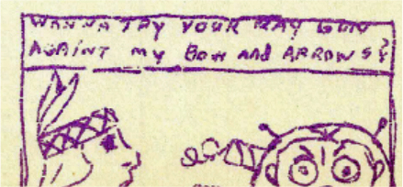

FOURTH GRADE
Mrs. Stephenson’s
The Fourth grade has elected new Class Officers. They are:
President – Randy Wingard
Vice-President – David Martindale
Secretary – Micki Brockwell
Randy has appointed committees for the Valentine Party and they are planning for the nicest party ever. James Keel is the chairman of the decorating committee and I’m sure our room will be well decorated. Randy is also trying to help us have better programs for opening exercises so they won’t all be too much alike.
We have a new pupil, Billy Case. He attended Springdale before coming to Lawler. He is interested in Science. He showed the class how to put an egg in a bottle by changing the air pressure.
We have three boys who entered the contest to become Junior Police Chief. They were VERNON HILL, JAMES RODGERS, and CLYDE JOHNSON.
Our room reporters are Patricia Hooper and Charles Collum. They were chosen by the class.

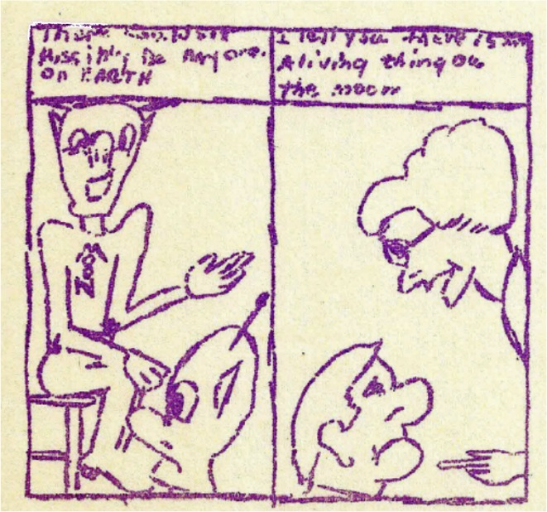

THIRD GRADE
MRS. MCATEE
CAT
The black cat yawns
Open her jaws,
Stretches her legs
And shows her claws,
Then she gets up
And stands on four
Long stiff legs
And yawns some more.
She shows her sharp teeth
She stretches her lips,
Her slice of a tongue
Turns up at the tip.
Lifting herself
On her delicate toes,
She arches her back
As high as it goes,
She lets herself down
With particular care,
And pads sway,
With her tail in the air.

* * * *
CUB SCOUTS
By Jim Seale
The Cub Scouts of America have fun at meetings. We make things. We play games. We have sixteen in our room. When summer comes we can go to camp. We earn badges. We learn Indian talk. We put on plays for our mother and fathers.
We have been making a book about animal stories in our room, each one wrote a story about an animal.
* * * *
MY PIG
By Roy Fisher
I have a little pig. He loves muddy water. He does not like baths. He loves slop and that’s what I feed him. He likes corn a whole lot.

An original story:
SUNSHINE
Once a long time ago there was a dog named “Shaggy.” She was a very faithful dog and always obeyed her master. One day Shaggy and her master were going on a walk in the park when without warning a breeze blew up and grew into a strong wind. The master said, “Shaggy, we had better get home while we can.”
The wind was blowing hard. They had just made it home when there was a broadcast. In the middle of a broadcast a man said, “We interrupt this program to give you an important bulletin. There is a hurricane approaching. It will arrive tonight and probably last until tomorrow at 6:00 P.M.”
The master hurried to get his family into the basement and put Shaggy into the shed. About midnight there as a big crash. The master looked out, but he could not see anything because it was so dark. He was worried all night, but when the hurricane was over he saw that the shed had been crushed by a tree.
He ran out and searched.in vain. He turned around and started to the house when he heard a joyful bark. He ran in the direction of the bark and found Shaggy under the house, but he also found five puppies.
He was so happy everything had turned out so well that he named one of the puppies “Sunshine.”
Johnny Boyd
* * * *

SPRING
The birds and the bees
Go wonderfully
With the trees.
The flowers and the brees,
Go wonderfully
With the bees.
Susan Neal
* * * *

A FRIGHTENING EXPERIENCE
On my vacation this summer I had a frightening experience.
I was with my aunt and her friend on a train going to Chicago. When we got to Fulton, Kentucky I had my experience.
The train stopped in Fulton. Outside, there was a stand where we could get ice cream, coffee, or a coke. We all got off. My aunt got some coffee and I got a coke. Just as my aunt’s friend started to get her coffee the conductor called, “All Aboard.”
My aunt and her friend got on, and just as I started to get on the train began moving, and there I was.
For a moment I thought I would have to stay in Fulton. My aunt helped me up and I just made it.
Helen Walker, 5th Grade
* * * *
MY CAT RINA
I have a Siamese cat named Rima. She has a crooked tail. She has dark blue eyes and she is four years old.
When Rina was little and didn’t know any better she ran away from home and we found her at a home by Sears.
When she was three and a half years old she ate a hole in Mother’s pumpkin pie and tore the paper off a brand new ham and ate a hole in that too.
I was running hot water in the bathtub one day and all cats with curiosity, she jumped in and almost lost one of her nine lives. After that she jumped upon mother’s silk tablecloth and almost broke Mother’s glass lazy susan.
One time she jumped into Mother’s cupboard, but she didn’t break Mother’s crystal and china. She has learned to behave better now and we all love her.
Elaine Cannon, 6th Grade
* * * *

MRS. SMITH’S FIFTH GRADE NEWS
Book Club
Mrs. Smith’s fifth grade has a Book Club. We choose five or six boys or girls to give reports on books they have read.

Janice Clements is our president and Norma Jean Ballard is the secretary. We have read many interesting books.
Norma Ballard
Class News
Janice Clements is president of our class. She has charge of our opening exercises every morning.
Chris Towns is vice-president and Norma Jean Ballard is secretary.
Our game captains, Ronnie Kills, Phillip Crouch, Norma Jean Clark, and Dorothy Turnbow have had good group games at recess periods.
Johnny Owin and Jerry Brockwell take good care of our books that we keep on our book shelves.
We like to keep our room looking nice, so Margaret Gordon, Peggy Fisher, and Janice Fisher help with that every morning.

* * * *
HEADS AND HEALTH
By
Johnny Reed
(Mrs. Smith’s Fifth Grade)
I have been collecting heads for four months and enjoy it.
You can learn many things about your head from looking at the heads I have dug up. You can learn many things about your teeth, ears, eyes, and mouth. I have learned many things from the heads I dug up.
I have dug twelve heads. Three of them were good. I dug up Indian heads. I found out that the Indians’ teeth were very clean. They had scarcely any cavities.
If we would take as good care of our teeth and body as they did, we would be very clean and healthy.
* * * *

‘THE FISH WITH THE DEEP SEA SMILE’
Patsy Austin, Mrs. Smith’s 5th grade
They fished and they fished
Way down in the sea,
Down in the sea a mile,
They fished among all the fish in the sea
For the fish with the deep sea smile

One fish came up from the deep of the sea,
From down in the sea a mile,
It had blue-green eyes,
And whiskers three,
But never a deep sea smile.

One fish came up from the deep of the sea,
From down in the sea a mile,
With electric lights up and down his tail,
But never a deep see smile

And then one day they got a pull,
From down in the sea a mile,
And when they pulled the fish into the boat,
He had a deep sea smile.

And as he smiled, the gook got free
And then, what a deep sea smile@
He flipped his tail and swam away,
Down in the sea a mile

* * * *
IF I WERE KING
I often wish I were a King
And then I could do anything.

If only I were King of Spain,
I’d take my hat off in the rain.

If I were King of France
I wouldn’t brush my hair for aunts.

I think, If I were King of Greece,
I’d push tings off the mantel piece.

If I were King of anything
I’d tell the soldiers I’s the King

Sandra Parks
Mrs. Smith’s Fifth Grade

ICE SKATING

I find ice skating a wonderful sport. It teaches you coordination and balance, besides being very relaxing. I can stop, do a double flat-foot spin, turn around, skate on both edges, and cut corners. The hardest thing to learn is to keep your ankles upright. With a little practice and time it will come naturally. If you feel yourself falling, relax. The ice will feel much softer if you don’t stiffen out.
Kathy Braswell
Sports Editor – 6th Grade

* * * *
SPORTS
I have many sports. One is golf. Golf is good for you and it is fun too. A lot of people think it is hard, but it is easy. It is hard to be an expert, buy you can learn.
My best sport is hunting. I have three guns of my own. I collect model guns and put them on my wall. I have a .22, a 420, and a BB gun.
Robert Wetzel – 6th Grade
* * * *
SNOW
The fence post were marshmallow hats
On a snowy day
Bushes in their nightgowns are
Kneeling down to pray.
And all the trees have silver skirts
And want to dance away.

Billy & Jeanne Hale
* * * *
Milky Moola is a man from Mars
You wouldn’t think he came from the Stars
Milky Moola is from the Milky Way
He is shaped like this to say

Mike Towns

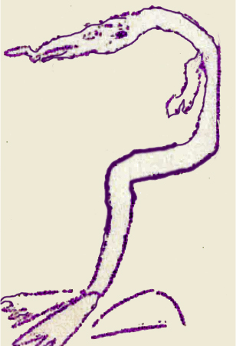

WATER SKIING

My favorite sport is water skiing.
When I go skiing in the summer I go with my family and friends to McKellar Lake.
I learned how to ski when I was nine years old.
Water skiing seems hard, and it is if you are a beginner, but after a while it becomes easy.
This summer I am determined to learn how to ski on one ski.
One of the skiing tricks which I think is difficult to do is the crisscross. In doing the crisscross one skier goes under the rope of another skier and keeps going back and forth. I think water skiing is fun.

Sally Belote, 6th Grade

* * * *
PUPPET GUILD OF MEMPHIS

The Puppet Guild of Memphis will sponsor a marionette show, “Pinocchio” by the nationally famous Suzari Puppeteers from New York City, at the Memphis State University Auditorium on Saturday morning, May 10, at 10 O’clock. The admission will be 60 cents. Both adults and children will enjoy the show.
Let’s everybody plan to see the show.
* * * *
A LITTLE BIRD’S NEST

I found a nest
In the Hawthorne tree,
The tiniest nest
I ever did see!
From what I’ve heard
I think it’s the nest
Of a hummingbird.

Owen Simpson

* * * *

SAFETY NEWS
The Lawler School Safety Council is composed of fourteen boys, which work on four corners. There are eight girls who stand on the stairs in the school building. The captain of the boys Safety Patrol is JERRY PATTON. The girls’ captain is LINDA WHITE.
The girls’ duties are to keep the children from running, sliding on the banisters, and to try to keep them from getting hurt. The boys are to see them safely across the street.
We have a meeting once a month at school. At the safety programs to see films and hear talks on safety. There are three city-wide meetings a year at the Linden Circle Theater. DAVID JOHNSON is our president. The vice-president is JEANNE HALE. JEANNETTE FOX is our secretary. Hot chocolate is served to the safety boys in the cafeteria on cold mornings.
All the safety members of our school and other schools are invited February 8th to go to the Shrine Circus.
Mr. Warren Chaille is our Kiwanis sponsor. He comes to our meetings occasionally. He gives talks and shows films. He comes to our city-wide meetings too.
Lt. O’Kelly and Capt. Glisson come and visit us each year. Lt. O’Kelly plays the guitar and Capt. Glisson plays the accordion. They bring their instruments and play music for us.
Linda White and Carole Boyde, 6th Grade
* * * *
BIBLE THOUGHTS FOR THE WEEK:
SUNDAY: Genesis 2:2
MONDAY: Deut. 31:6
TUESDAY: Proverbs 30:33
WEDNESDAY: John 3:16
THURSDAY: Matthew 4:7
FRIDAY: Psalms 7:1
SATURDAY: Revelations 22:31
Cheryl Simon

MY PET PUPPY
I have a cute little puppy dog with black and white floppy ears. She can jump through a loop. Her name is Lady. She tried to follow my friends to school.
Sunday I was teaching her to bring the paper to my Daddy. But, she only brings sticks and balls to you.
We got a bird on a stick that sounds like a real one. Lady tries to catch it, but it is no use.
She is very fond of children. She loves to play with them. She went on a club hike and got very tired. We had to carry her all the way back.
She is very lazy. She puts her hind legs straight back and goes to sleep.
Emilie Sue Cannon, 6th Grade
* * * *
PATHWAYS TO HEALTH
Danny Tarver, 6th Grade

Everyone wants to have friends. A healthy person has many friends. There is a very important friend. Can you guess who it is? YOURSELF. Some of the ways to be a friend to yourself are:
Have plenty of sunshine.
Have at least two hours of outdoor exercise each day.
Sleep eleven hours at night.
Brush your teeth regularly.
Keep the windows open at night.
Wash your hands before eating.
Drink safe water.
Drink at least three glasses of milk daily.
Drink no tea or coffee.
Chew fool thoroughly.
Eat a green leafy vegetable each day
Don’t eat candy between meals.
Use correct lighting for reading and writing.
Wear loose clothing.
How good a friend are you to yourself? Can you think of any other helpful habits?

MY HOBBIES
One of my hobbies is reading. Recently I have been reading a series of books about Joan Foster.
Another is Spelling. Lately I have been studying for the Spelling Bee.
I am also a member of several organizations. I am a member of the Girls’ Auxiliary of Merton Avenue Baptist Church and the Junior Choir of Merton Avenue Baptist Church.
I also love to skate. The girls across the street and I have made skating at Skateland a regular Saturday occasion.
Helen Walker, 6th Grade
* * * *
MY HOBBY
Abraham Fixman, 6th Grade
My hobby is collecting stamps. I have been collecting for four years. I collect foreign stamps and United States Stamps.
My uncle bought me my first album. It has a place for foreign stamps and flags. Now I have two stamp albums.
I think stamps collecting is a lot of fun. I hope you start to collect stamps.
* * * *
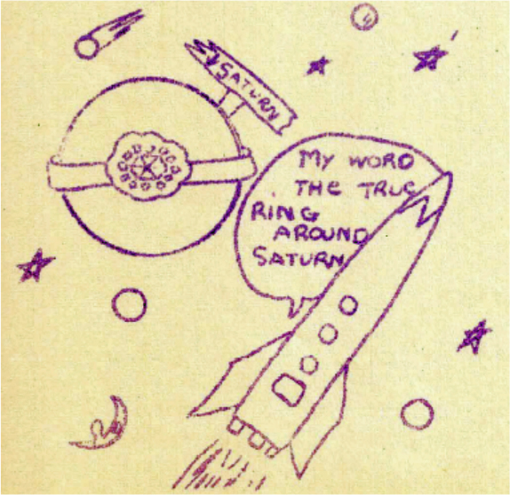

FLYAWAY AT THE AIR CIRCUS
Selected by: Carl Sherman

Out at the airfield of a big city a little airplane named FLYAWAY rested on the ground. Flyaway had just come from the airplane factory.
Flyaway stretched his new red wings out in the warm sun. He turned his new red nose up toward the sky. He watched the other airplanes banking and turning in the air.
“Tomorrow!” he whispered, “oh, tomorrow I’ll be up there too!”
* * * *
PEANUT BOYS
Seven little peanut boys each with a hat.
The first one said, “Let’s scare the cat.”
The second one said, “We’ll watch him run.”
The third one said, “It’s a lot of fun.”
The fourth one said, “We’ve no fear.”
The fifth one said, “That’s what I hear.”
Seven little peanut boys running from the cat.
Upside down on each little cat.
Nancy Russell, 6th grade
* * * *
MY FAVORITE STORY
Jeanne Hale

My favorite sport is Ice Skating. I just started this hobby about two months ago. I can skate forward, then backward. In the end I am doing the crossover. This stunt is very difficult
I can also do this – skate backward whirl in the air, and slide.
I enjoy ice skating very much. It is a good sport all year around.
* * * *

SIXTH GRADE CLASS NEWS
On Tuesday, January 14th, Mrs. R. A. Braswell came to visit us. She brought some film slides her husband had taken in Europe. They were titled “Smidge Visits Europe.”
Smidge is a Dalmatian dog owned by Mrs. Braswell. Although Smidge did not really go there, it added some good humor to the slides.
The films showed pictures of naval ships and airplanes which were of great interest to the boys. The girls liked shots of Pompeii and Athens very much, but all were beautiful in color. The countries visited were Spain, France, Italy, Greece, and Rhodes.
Kathy Braswell
* * * *
MOTHERS AND FATHERS
Mothers and Fathers,
Mothers and Fathers,
Try to teach you to be nice.
Mothers and Fathers,
Mothers and Fathers,
Teach you to be nice at other people’s houses
Mothers and Fathers,
Mothers and Fathers,
Try to teach you to grow up to be
GENTLEMEN AND LADIES

Billy Joe House, 6th Grade
* * * *
SOCIETY NEWS
ROLLER SKATING
Every Friday night DAVID JOHNSTON, SHIRLEY BRAY, CAROL and JOHNNY BOYD, JEANETTE FOX, and NANCY RUSSEL, a group from the 6th grade, go Roller Skating at Skateland. We have a lot of fun.
VALENTINE PARTY
Mrs. Fixman and Mrs. Fox, the 6th grade room sponsors, are giving us a Valentine Party. We will have refreshments and games. We are looking forward to it.
Shirley Bray, Society Editor, 6th Grade
* * * *

SHRINE CIRCUS
Saturday February 8th is the day for the Safety Council to go to the Shrine Circus. I know it will be a lot of fun.
Shirley Bray
* * * *
BLACKIE AND CORKIE
A boy named Billy Joe Howse had two dogs named Blackie and Corky. They always liked to go racing around the block. When Billy had Blackie and Corky tied to him he would outrun his brother Lynn.
One day Corky was bitten by a rat and Billy’s mother took Corky to the doctor and the doctor said he must be put to sleep.
Blackie cried all night for a week. He got sick and Billy’s mother said that Blackie had sore ears. They had to take him to the doctor for two weeks and after a while he was all right.
About four weeks later his ears started to get sore again. Billy’s mother took him back again and the doctor said he would be all right.
Later Billy’s father got killed and his grandmother came to live with his family and they had to give Blackie away.
Billy Joe Howse, 6th Grade
* * * *
“MUTNICK”
(An Original Poem)
I have a dog at my house.
He’s just a shaggy mutt.
I play and wrestle with him
And gee! Do we have fun?
His name is Mutnick.
Quite funny, isn’t it?
But he doesn’t seem to mind
So I suppose he shall keep it.
He sleeps beside my bed at night.
My mother doesn’t think it’s right
But because I love him so.
He must always stay by my side.

Jeanette Fox
* * * *

GEORGE WASHINGTON PUZZLE
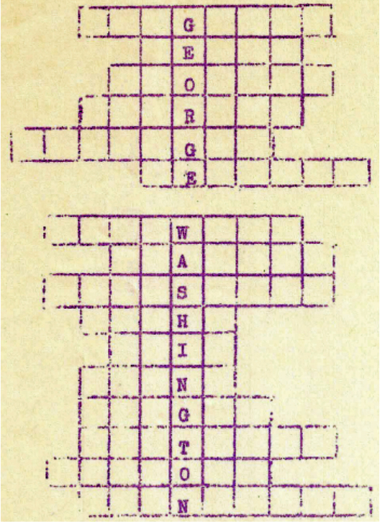
(Answers Last Page)
Find the correct place in the Puzzle for each of these States.
GEORGIA VERMONT MICHIGAN
ALABAMA VIRGINIA DELAWARE
OHIO MAINE KENTUCKY
TEXAS LOUISIANA FLORIDA
MINNESOTA WYOMING OREGON
IDAHO

By: Chris Towns, Mrs. Smith’s 5th Grade
RIDDLES #2
1. If a man sent his son to college these days and paid a thousand dollars a year to put him through, how much change would he get back?
2. Why is tennis such a noisy game?
3. A train ran off a bridge and no one was hurt. How come?
4. What international crisis would a waiter cause if he dropped a platter on Thanksgiving?
* * * *
RIDDLES #1
1. What becomes higher when the head is removed?
2. What is a bull called when he’s sleeping?
3. What did the ocean say to the seashore?
4. When is it easiest to read in the woods?
5. What is it that you remove the outside, cook the inside, eat the outside and throw away the inside?
(Answers on Last Page)
BY: Martha Tedford, Mrs. Smith’s 5th Grade
RIDDLES #2
(Continued)
5. What kind of ears does an engine have?
By: Margaret Gordon, Mrs. Smith’s 5th Grade
** J O K E S**
Helen Jones
Mrs. Smith’s 5th Grade

DOCTOR: How is the boy that swallowed the half-dollar?
NURSE: No change yet, Doctor.
* * * *
JOE: Mother, may I have the wishbone?
MOTHER: Not until you’ve eaten your vegetables.
JOE: But, Mother, I want to wish that I don’t have to eat them.
* * * *

Answers to GEORGE WASHINGTON
VIRGINIA
TEXAS
WYOMING
FLORIDA
MICHIGAN
GEORGIA

DELAWARE
ALABAMA
LOUISIANA
IDAHO
OHIO
MAINE
OREGON
KENTUCKY
VERMONT
MINNESOTA
Answer to RIDDLES #2
1. He might get a quarterback.
2. Because each player raises a racket.
3. It ran off the bridge at one end as usual.
4. It would be the downfall of Turkey, the overthrow of Greece, and the destruction of China.
5. Engineers.
* * * *
RAIN CHILDREN
Lilly and Jeanne Hale

They’re dashing at the window pane.
They’re jumping on the sill.
They’re diving into puddles.
They just cannot be still

* * * *
***FAST FINISH***
Helen Jones, 5th Grade

DEALER: This car will go 135 miles an hour.
BUYER: Yes, go on.
DEALER: And, it will stop on a dime.
BUYER: Yes, go on, what happens next?
DEALER: Well, a putty knife comes out and wipes you off the windshield.
* * * *
LAUGH WITH JOY HULL
Miss Smith’s Room

CITY BOY: Look at that bunch of cows grazing.
FARM BOY: Not bunch – herd.
CITY BOY: Heard what?
FARM BOY: Herd of cows.
CITY BOY: Sure, I’ve heard of cows.
FARM BOY: No, I mean a cow herd.
CITY BOY: So what if a how heard –
I haven’t been telling any secrets.
* * * *
LITTLE BOY: I’m calling to make an appointment with the doctor.
NURSE: I’m sorry, he’s out.
LITTLE BOY: Thank you! When will he be out again?
* * * *
LOU: Did the teacher really say your voice was heavenly?
SHE: Well, she said it was unearthly
* * * *
JOE: Did you hear about the soldier who marched all day and only moved two feet?
PETE: No, how did that happen?
JOE: That was all he had.
* * * *

WATER
Shallow water,
Water that runs over my feet.

Cool water,
Muddy water,
Oops – a slick stone in the deep.
Damp water,
Wet water,
Now look – water over my seat.

Carol Veazey, Mrs. Smith’s 5th Grade
* * * *
CONSECRATION
I consecrate my life to Him,
Who gave His life for me;
I pledge to read His precious Word
And hear His earnest plea.

I wish to follow in His path,
And hear Him when He calls.
Aware that life is waiting near,
When just a sparrow falls.

Because I wish to live for Him,
I bow and humbly pray.
That He will give me needed strength,
Renewing it each Day.
Florence P. Jansson
(Pat’s favorite one)
* * * *
How many sides has a circle got?
(Two – Inside and outside)

What is the worse weather for mice and rats?
(When it’s raining cats and dogs)
What is your very last teeth called?
(False teeth)

Why did the little moron take a ladder to school with him?
(He was in high school)

Why did the gun fighter take a ladder to the gun fight?
(It was a high noon)
Ronnie McPhial
* * * *

JACKS AND MARBLES
Jacks and girls go together
On a summer day.

Marbles and boys in a circle
That’s the way they play.

Jacks and marbles.
Girls and boys.
All summer they do say,
“Come friend, let us play today!”

Kathie Wessels, Miss Burgess’ 5th Grade
* * * *

SCHOOL TUNE
What did you do at school,
Billy Boy, Billy Boy?
Oh, what did you do at school,
My dear Billy?

I have tried to study hard,
That is all, that is all
I have tried to study hard,
But I failed.

Don’t you think you could do better
Billy Boy, Billy Boy?
Oh, don’t you think you could do better,
My dear Billy?

Yes, I will do better,
That I promise, that I promise.
Yes, I will do better,
That I promise.

* * * *
WHEN I WAS COASTING
When I was coasting on the hill
One winter morning long ago,
I went so fast the earth was still
And all the clouds were whirling so,
I left the earth and took the air,
And might be, still be, rising there
Had not a woodpile and a tree
Come falling up and met with me.

Sharon West & her mother

* * * *

BOOK REPORTS

“BEST FRIENDS”
(My favorite book is “ BEST FRIENDS”
It is about two girls,. One of the girls is French. Her name is Clothide (Coco) Langdon. The other girl is American. Her name is Susie Green.
It all starts with Susie in her tree house, looking with hopeful eyes at the “Pink House.” Susie usually pretends that movie stars live there, but today is different. There is a moving van in front of this beautiful house. Of course, Susie is excited, but she thinks it will be some old lady or man with no children at all, especially her age. So Susie picks up her books and begins to read. Then to her surprise, standing at the foot of the tree is a little French girl about her own age and height. Then this lady comes out of the pink house speaking in some awfully confusing language. Susie and the little French girl soon become very good friends. They have a lot of fun filled adventures together.
**Jeanette Fox**

BAMBI”
Idella Purnell
Mrs. Stephenson’s 4th Grade
The part I like best is THE YOUNG PRINCE, ALL OF THE ANIMALS WERE ASLEEP WHEN Thumper, the rabbit, came and woke them up. The rabbit was excited because a new prince was born. All of the rest of the animals followed Thumper to where this prince was born. After they stayed a while they went away.
Thumper was the; last one to leave. He asked the mother deer what she was going to name the new prince. She told him she was going to name his “Bambi.”
* * * *

BOOK REPORTS

“A FIRST BOOK IN AMERICAN HISTORY”
BY
Charles A. Beard & William G. Bagley
This book is about a story of our country. It tells how our nation, The United State, came to be what it is today. It will tell how brave men from Europe crossed the Atlantic Ocean in the hope that they might reach Asia, and how they found instead a great continent that no one living in Europe at that time had ever heard about. It will tell how other brave men explored this new land, some in search of gold and others to learn whether it would not be a place where people from Europe could settle and build homes and carry on farming and trade. It will tell how people did come from Europe to make homes, and how some of these, coming from England, settled along the eastern coast of North America. It will tell how these settlers cleared their fields and built their cabins. It will tell about some of the troubles that they had both with the savages and with settlers from other European countries. It will tell of the colonies that these English settlers founded, and how there colonies were so harshly treated by the mother country that they finally fought and won a bitter war and became free and independent “states,” bound together or “united” as a new nation. It will tell how this new nation grew and prospered until it became one of the largest and strongest nations in the world.
I like the book very much. I suggest you read it if you like History.
**Patricia Bargett**
* * * *
“Weather”
DICK: “Hey, Joe”
JOE: “Hey, Dick”
DICK: “How did you find the weather while you were away, Joe?”
JOE: “I just looked out and there it was.”
Linda White – 6th Grade
* * * *

